
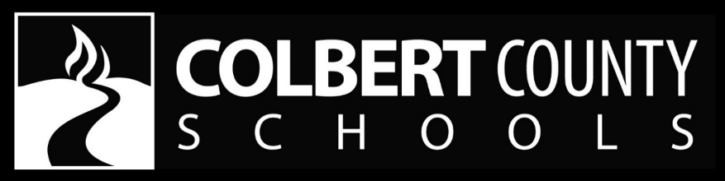
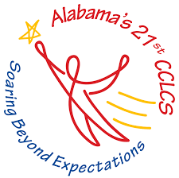
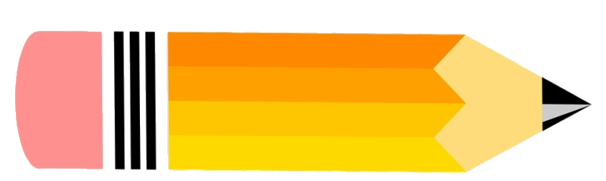



21st Century Community Learning Center
After School Program
21st Century Learning Centers will be located on the campuses of CES, CHES, LES and HES. Transportation will be available from NBES to CHES campus.
REGISTRATION OPEN NOW!
Contact your child’s teacher for a registration form.

Enrollment is limited.
For more information please contact Emily Counce or Brooke Cunningham at 256-386-8565.
Students will receive the following:
- Small group instruction
- Art & Music
- STEAM activities
- Enrichment activities
- Healthy Snack
- Physical Fitness
- And much more!

The Colbert County School District will be offering a free After School Program
beginning monday, August 4th, 2025

Registration for the 2025-2026 school year is now open! Enrollment is limited.
This program is available to all students’ grades Kindergarten-5th Grade.

Mondays - Fridays
3:00-5:30 p.m.

*Parents will be responsible for pick-up by 5:30 p.m. each day.

